Query the Name of any student in STUDENTS who scored higher than Marks. Order your output by the last three characters of each name. If two or more students both have names ending in the same last three characters (i.e.: Bobby, Robby, etc.), secondary sort them by ascending ID.
Input Format
The STUDENTS table is described as follows: 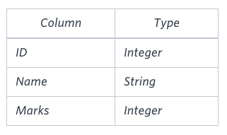 The Name column only contains uppercase (A-Z) and lowercase (a-z) letters.
Sample Input
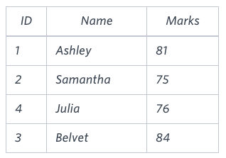

SELECT NAME FROM STUDENTS
WHERE MARKS>75
ORDER BY SUBSTRING(NAME,-3,3),ID

Amber's conglomerate corporation just acquired some new companies. Each of the companies follows this hierarchy: 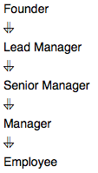
Given the table schemas below, write a query to print the company_code, founder name, total number of lead managers, total number of senior managers, total number of managers, and total number of employees. Order your output by ascending company_code.
Note:
- The tables may contain duplicate records.
- The company_code is string, so the sorting should not be numeric. For example, if the company_codes are C_1, C_2, and C_10, then the ascending company_codes will be C_1, C_10, and C_2.

Input Format
The following tables contain company data:
- Company: The company_code is the code of the company and founder is the founder of the company. 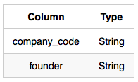
- Lead_Manager: The lead_manager_code is the code of the lead manager, and the company_code is the code of the working company. 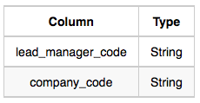
- Senior_Manager: The senior_manager_code is the code of the senior manager, the lead_manager_code is the code of its lead manager, and the company_code is the code of the working company. 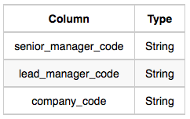
- Manager: The manager_code is the code of the manager, the senior_manager_code is the code of its senior manager, the lead_manager_code is the code of its lead manager, and the company_code is the code of the working company. 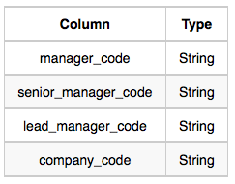
- Employee: The employee_code is the code of the employee, the manager_code is the code of its manager, the senior_manager_code is the code of its senior manager, the lead_manager_code is the code of its lead manager, and the company_code is the code of the working company. 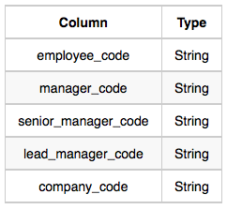

Sample Input
Company Table: 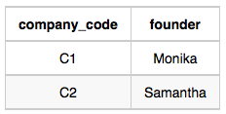 Lead_Manager Table: 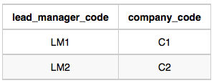 Senior_Manager Table: 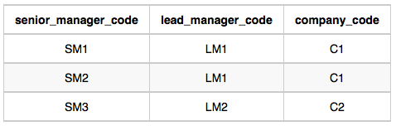 Manager Table: 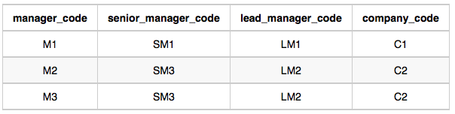 Employee Table: 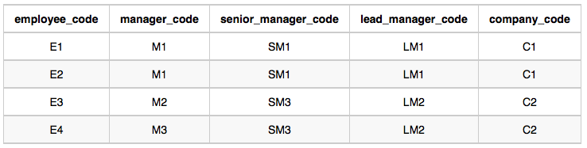
Sample Output
C1 Monika 1 2 1 2
C2 Samantha 1 1 2 2
Explanation
In company C1, the only lead manager is LM1. There are two senior managers, SM1 and SM2, under LM1. There is one manager, M1, under senior manager SM1. There are two employees, E1 and E2, under manager M1.
In company C2, the only lead manager is LM2. There is one senior manager, SM3, under LM2. There are two managers, M2 and M3, under senior manager SM3. There is one employee, E3, under manager M2, and another employee, E4, under manager, M3.
SELECT company_code, founder,COUNT(DISTINCT LEAD_MANAGER_CODE),COUNT(DISTINCT SENIOR_MANAGER_CODE),COUNT(DISTINCT MANAGER_CODE),COUNT(DISTINCT EMPLOYEE_CODE)
FROM
(SELECT C.COMPANY_CODE,C.FOUNDER,LM.LEAD_MANAGER_CODE,SM.SENIOR_MANAGER_CODE,M.MANAGER_CODE,E.EMPLOYEE_CODE FROM COMPANY C LEFT OUTER JOIN LEAD_MANAGER LM ON C.COMPANY_CODE=LM.COMPANY_CODE
LEFT OUTER JOIN SENIOR_MANAGER SM ON LM.COMPANY_CODE=SM.COMPANY_CODE
LEFT OUTER JOIN MANAGER M ON SM.COMPANY_CODE=M.COMPANY_CODE
LEFT OUTER JOIN EMPLOYEE E ON C.COMPANY_CODE=E.COMPANY_CODE)A

GROUP BY company_code,FOUNDER
ORDER BY company_code
Write a query identifying the type of each record in the TRIANGLES table using its three side lengths. Output one of the following statements for each record in the table:
- Equilateral: It's a triangle with sides of equal length.
- Isosceles: It's a triangle with sides of equal length.
- Scalene: It's a triangle with sides of differing lengths.
- Not A Triangle: The given values of A, B, and C don't form a triangle.
Input Format
The TRIANGLES table is described as follows:
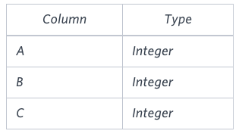
Each row in the table denotes the lengths of each of a triangle's three sides.
Sample Input
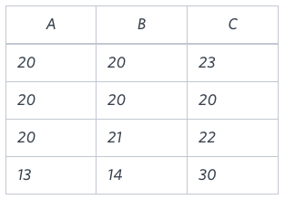
Sample Output
Isosceles
Equilateral
Scalene
Not A Triangle
Explanation
Values in the tuple form an Isosceles triangle, because .
Values in the tuple form an Equilateral triangle, because . Values in the tuple form a Scalene triangle, because .
Values in the tuple cannot form a triangle because the combined value of sides and is not larger than that of side .
______________________________________________________________________________________________________________
SELECT
CASE
WHEN (A > 0 AND B > 0 AND C > 0 AND (A + B > C) AND (B + C > A) AND (A + C > B))
THEN
(
CASE
WHEN (A = B AND B = C) THEN 'Equilateral'
WHEN (A = B OR B = C OR A = C) THEN 'Isosceles'
ELSE 'Scalene'
END
)
ELSE 'Not A Triangle'
END
FROM TRIANGLES;

